Lab-6 Basic OSPF Configuration and Analysis
Step 6: Examine and verify OSPF configurations.
Answer the following questions:
Q6-1.1. Paste the screenshot of the created topology.
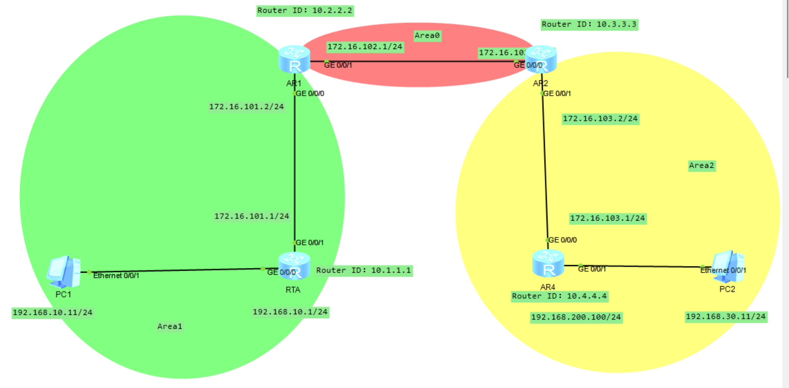
Q6-1.2. Paste the screenshots of the OSPF routing table, Link-State Database, OSPF neighbor, updates of the LSAs that the LSDB receives and route calculation statistics on the router RTA.
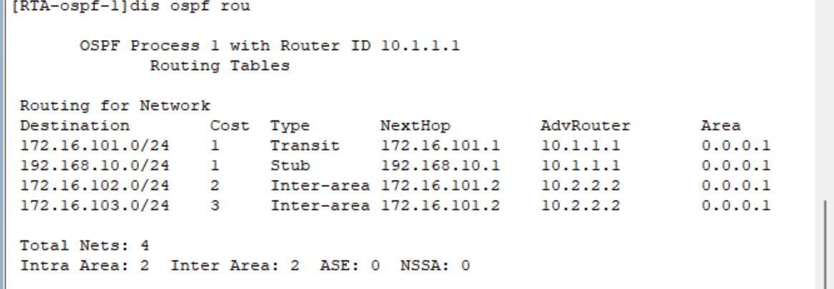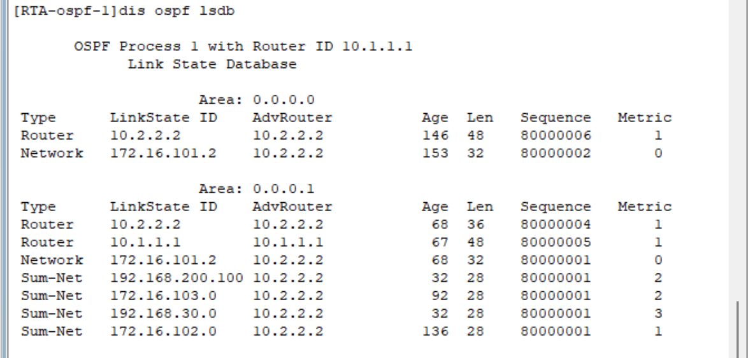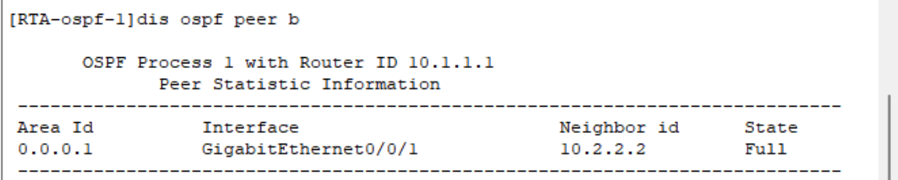
Q6-1.3. Paste the screenshots of the OSPF routing table, Link-State Database, OSPF neighbor, updates of the LSAs that the LSDB receives and route calculation statistics on the router RTB.
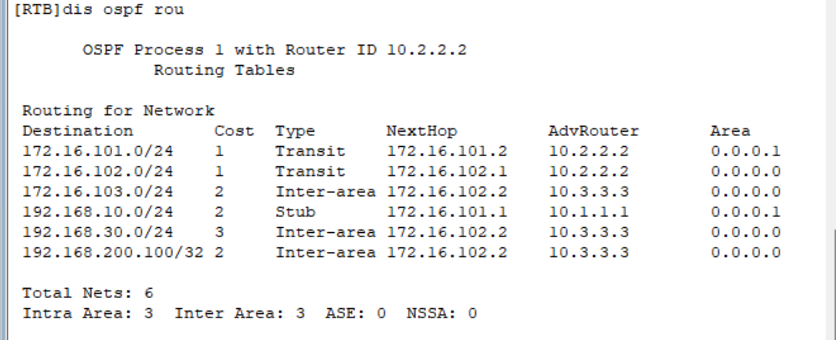
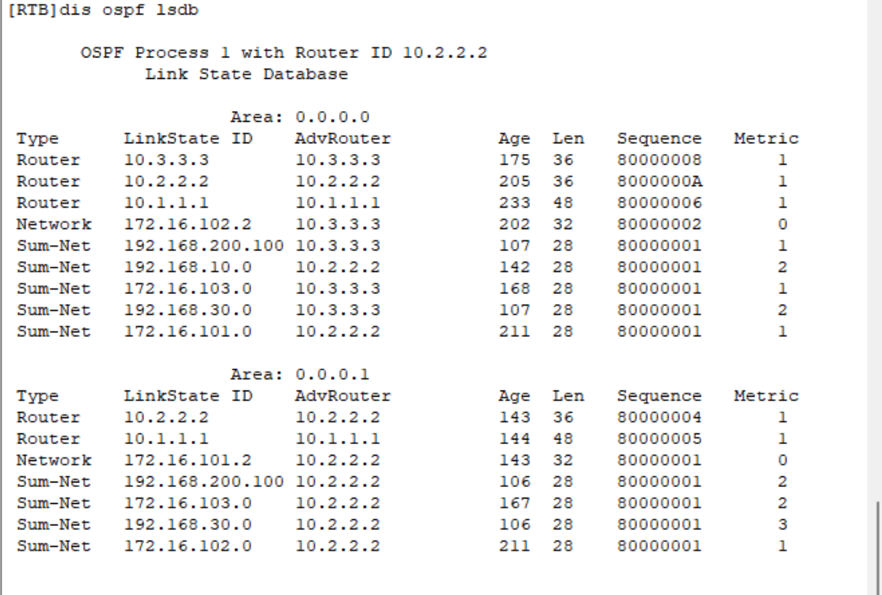
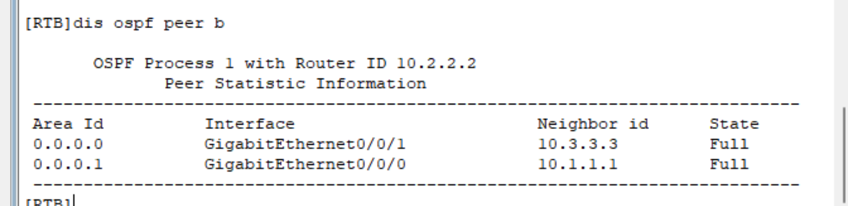
Q6-1.4. Paste the screenshots of the OSPF routing table, Link-State Database, OSPF neighbor, updates of the LSAs that the LSDB receives and route calculation statistics on the router RTC.
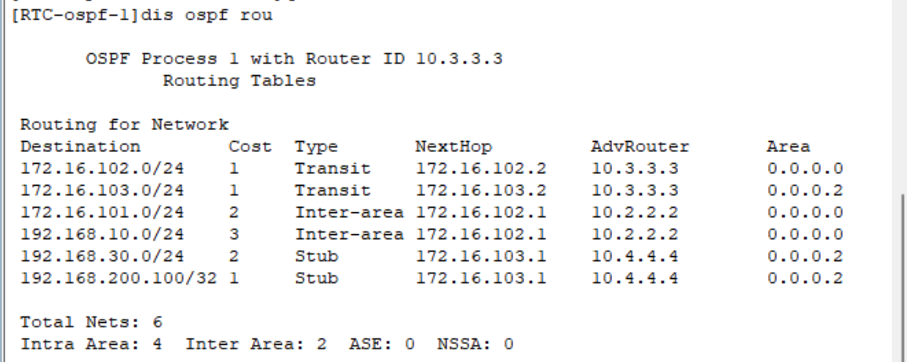
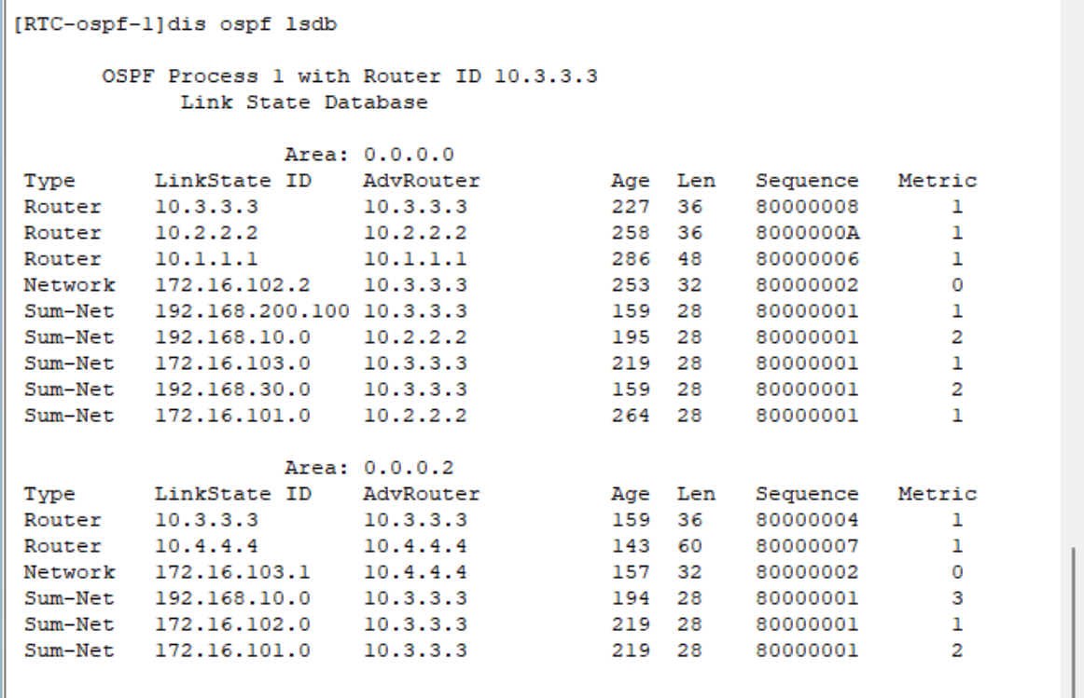
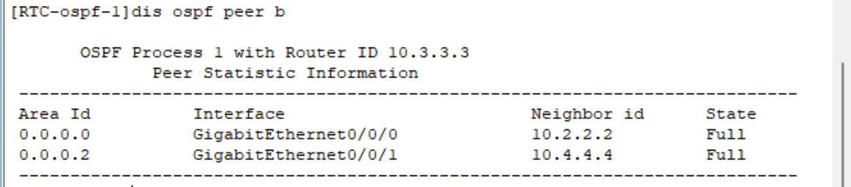

Q6-1.5. Paste the screenshots of the OSPF routing table, Link-State Database, OSPF neighbor, updates of the LSAs that the LSDB receives and route calculation statistics on the router RTD.
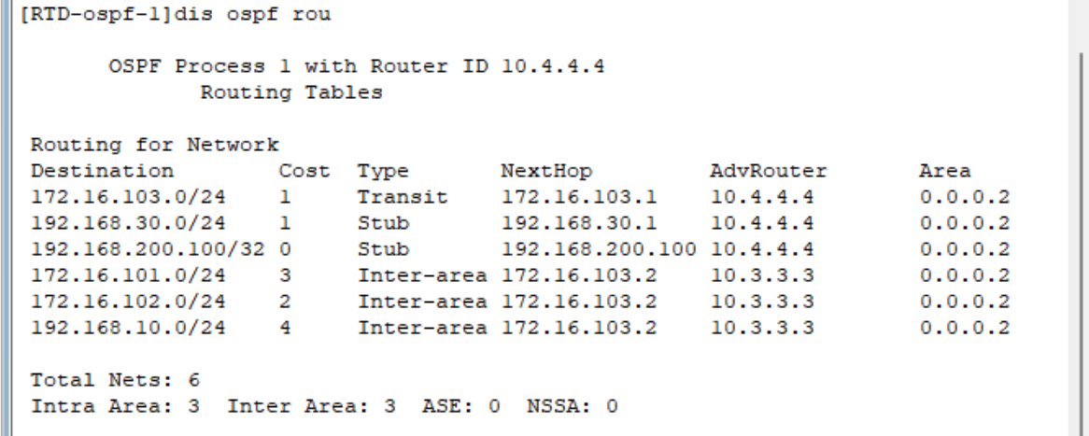
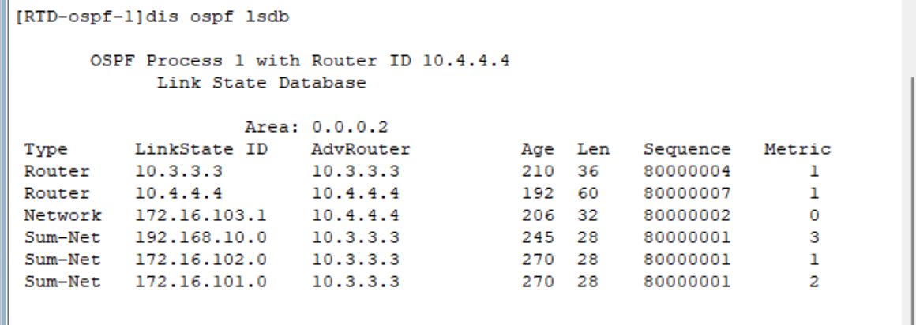
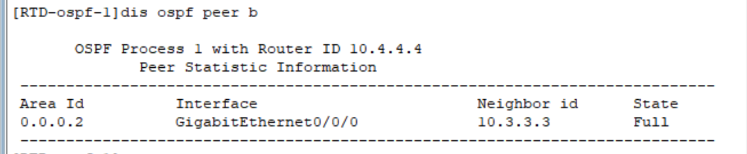

Q6-1.6. Can PC-10-1 and PC-30-1 ping each other? Please paste the screenshot of the ping result. ？
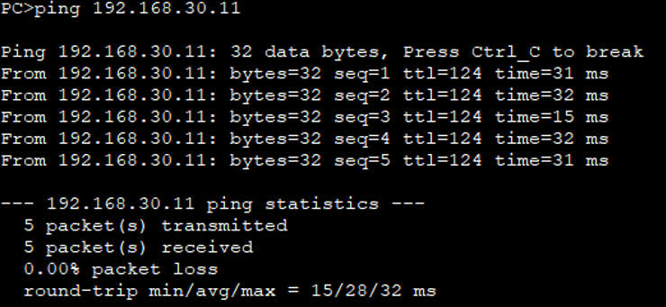
Q6-1.7. Can PC-10-1 and loopback 0 on RTD ping each other? Please paste the screenshot of the ping result.
YES, they can.
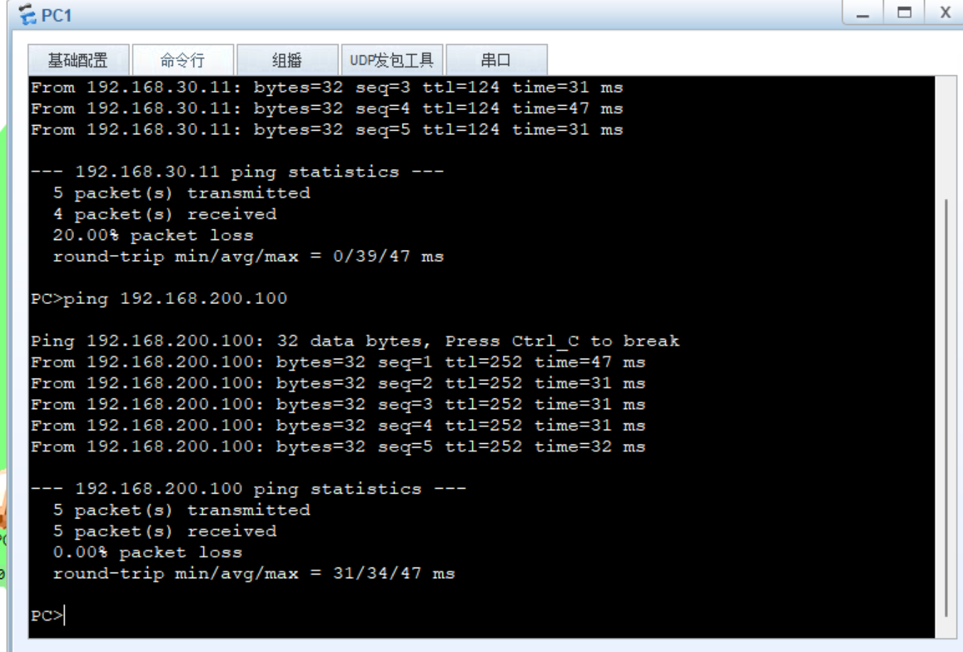
Q6-1.8. Please paste the screenshot of the result of command “tracert 192.168.30.11” issued from PC-10-1. YES, they can.
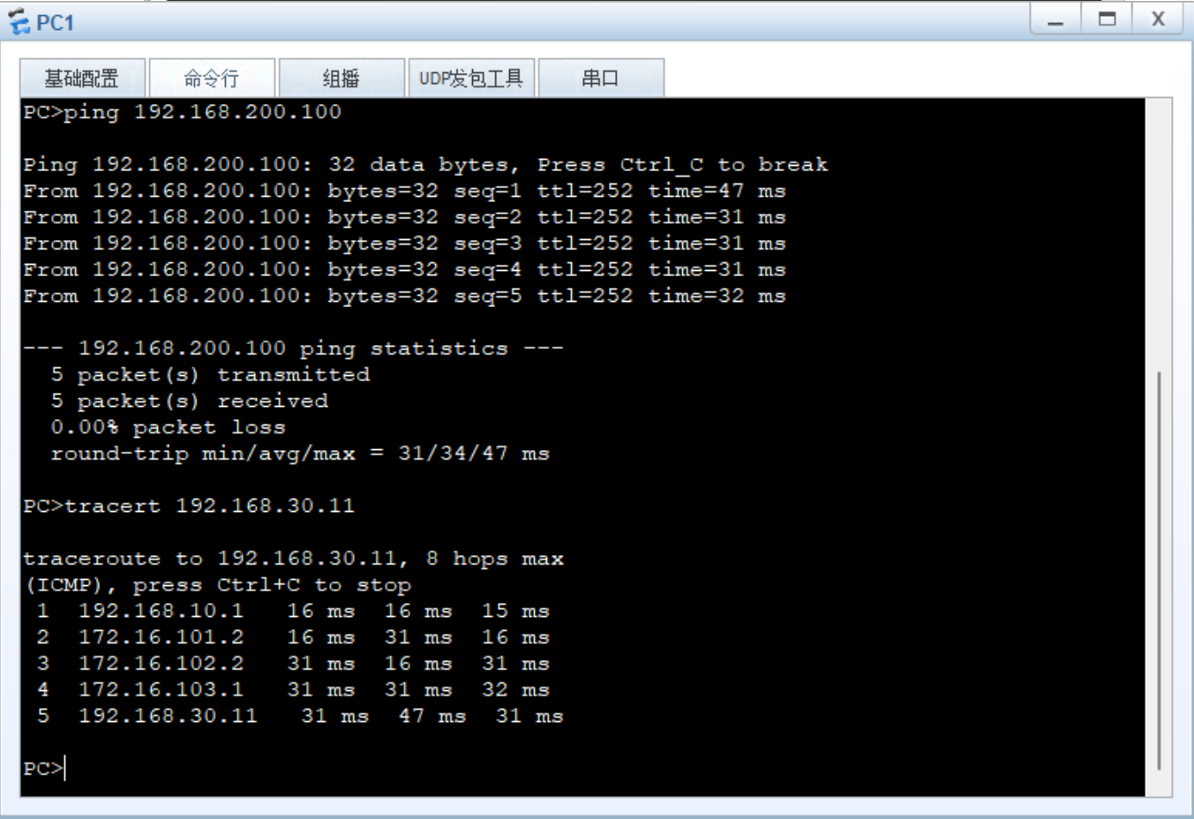
Q6-1.9. Just after configuring OSPF on RTA and RTB, what OSPF packets are exchanged between RTA and RTB? Please explain with the captured OSPF communications.
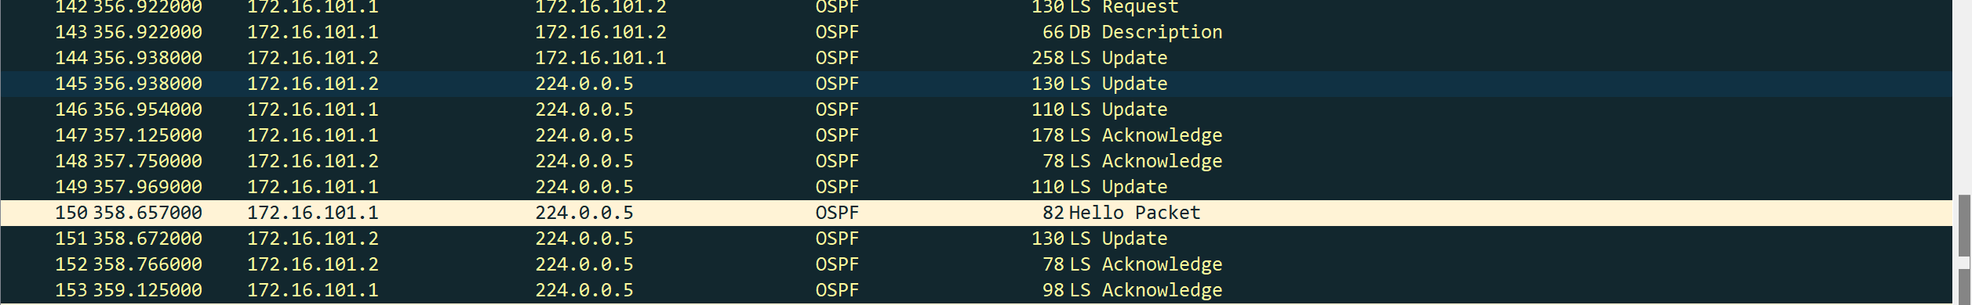
Hello packet is used for adjacency establishment and neighbor discovery.
Database Description (DD) packet is used for exchanging summarized link-state database information.
Link State Request (LSR) packet is used to request specific link-state information from a neighbor.
Link State Acknowledgment (LSAck) packet is used to acknowledge the successful receipt of link-state information.
Link State Update (LSU) packet is used to propagate updated link-state information throughout the network.
Q6-1.10. With the completion of the OSPF configurations on each router, how does RTA know that the network topology has changed? Please explain with the captured OSPF communications.
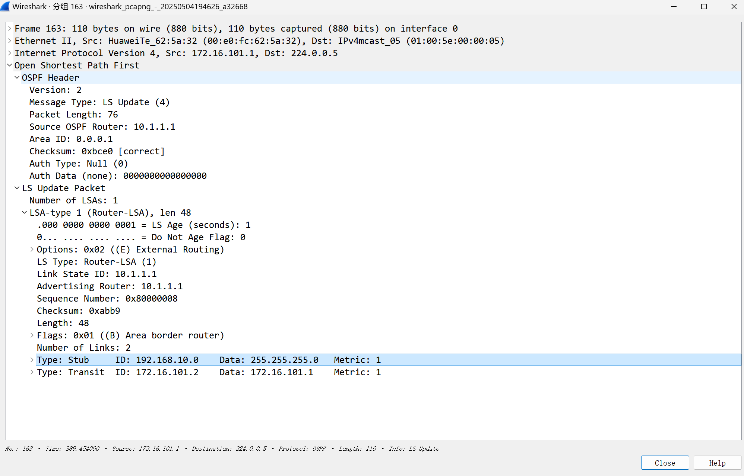
Link-State Advertisement (LSA) packet is used to describe and disseminate routing and topological information about the network.
Q6-1.11. What OSPF packets are sent and received from the interface GE 0/0/0 and GE 0/0/1 on RTB? Paste the screenshot of the captured OSPF packets.
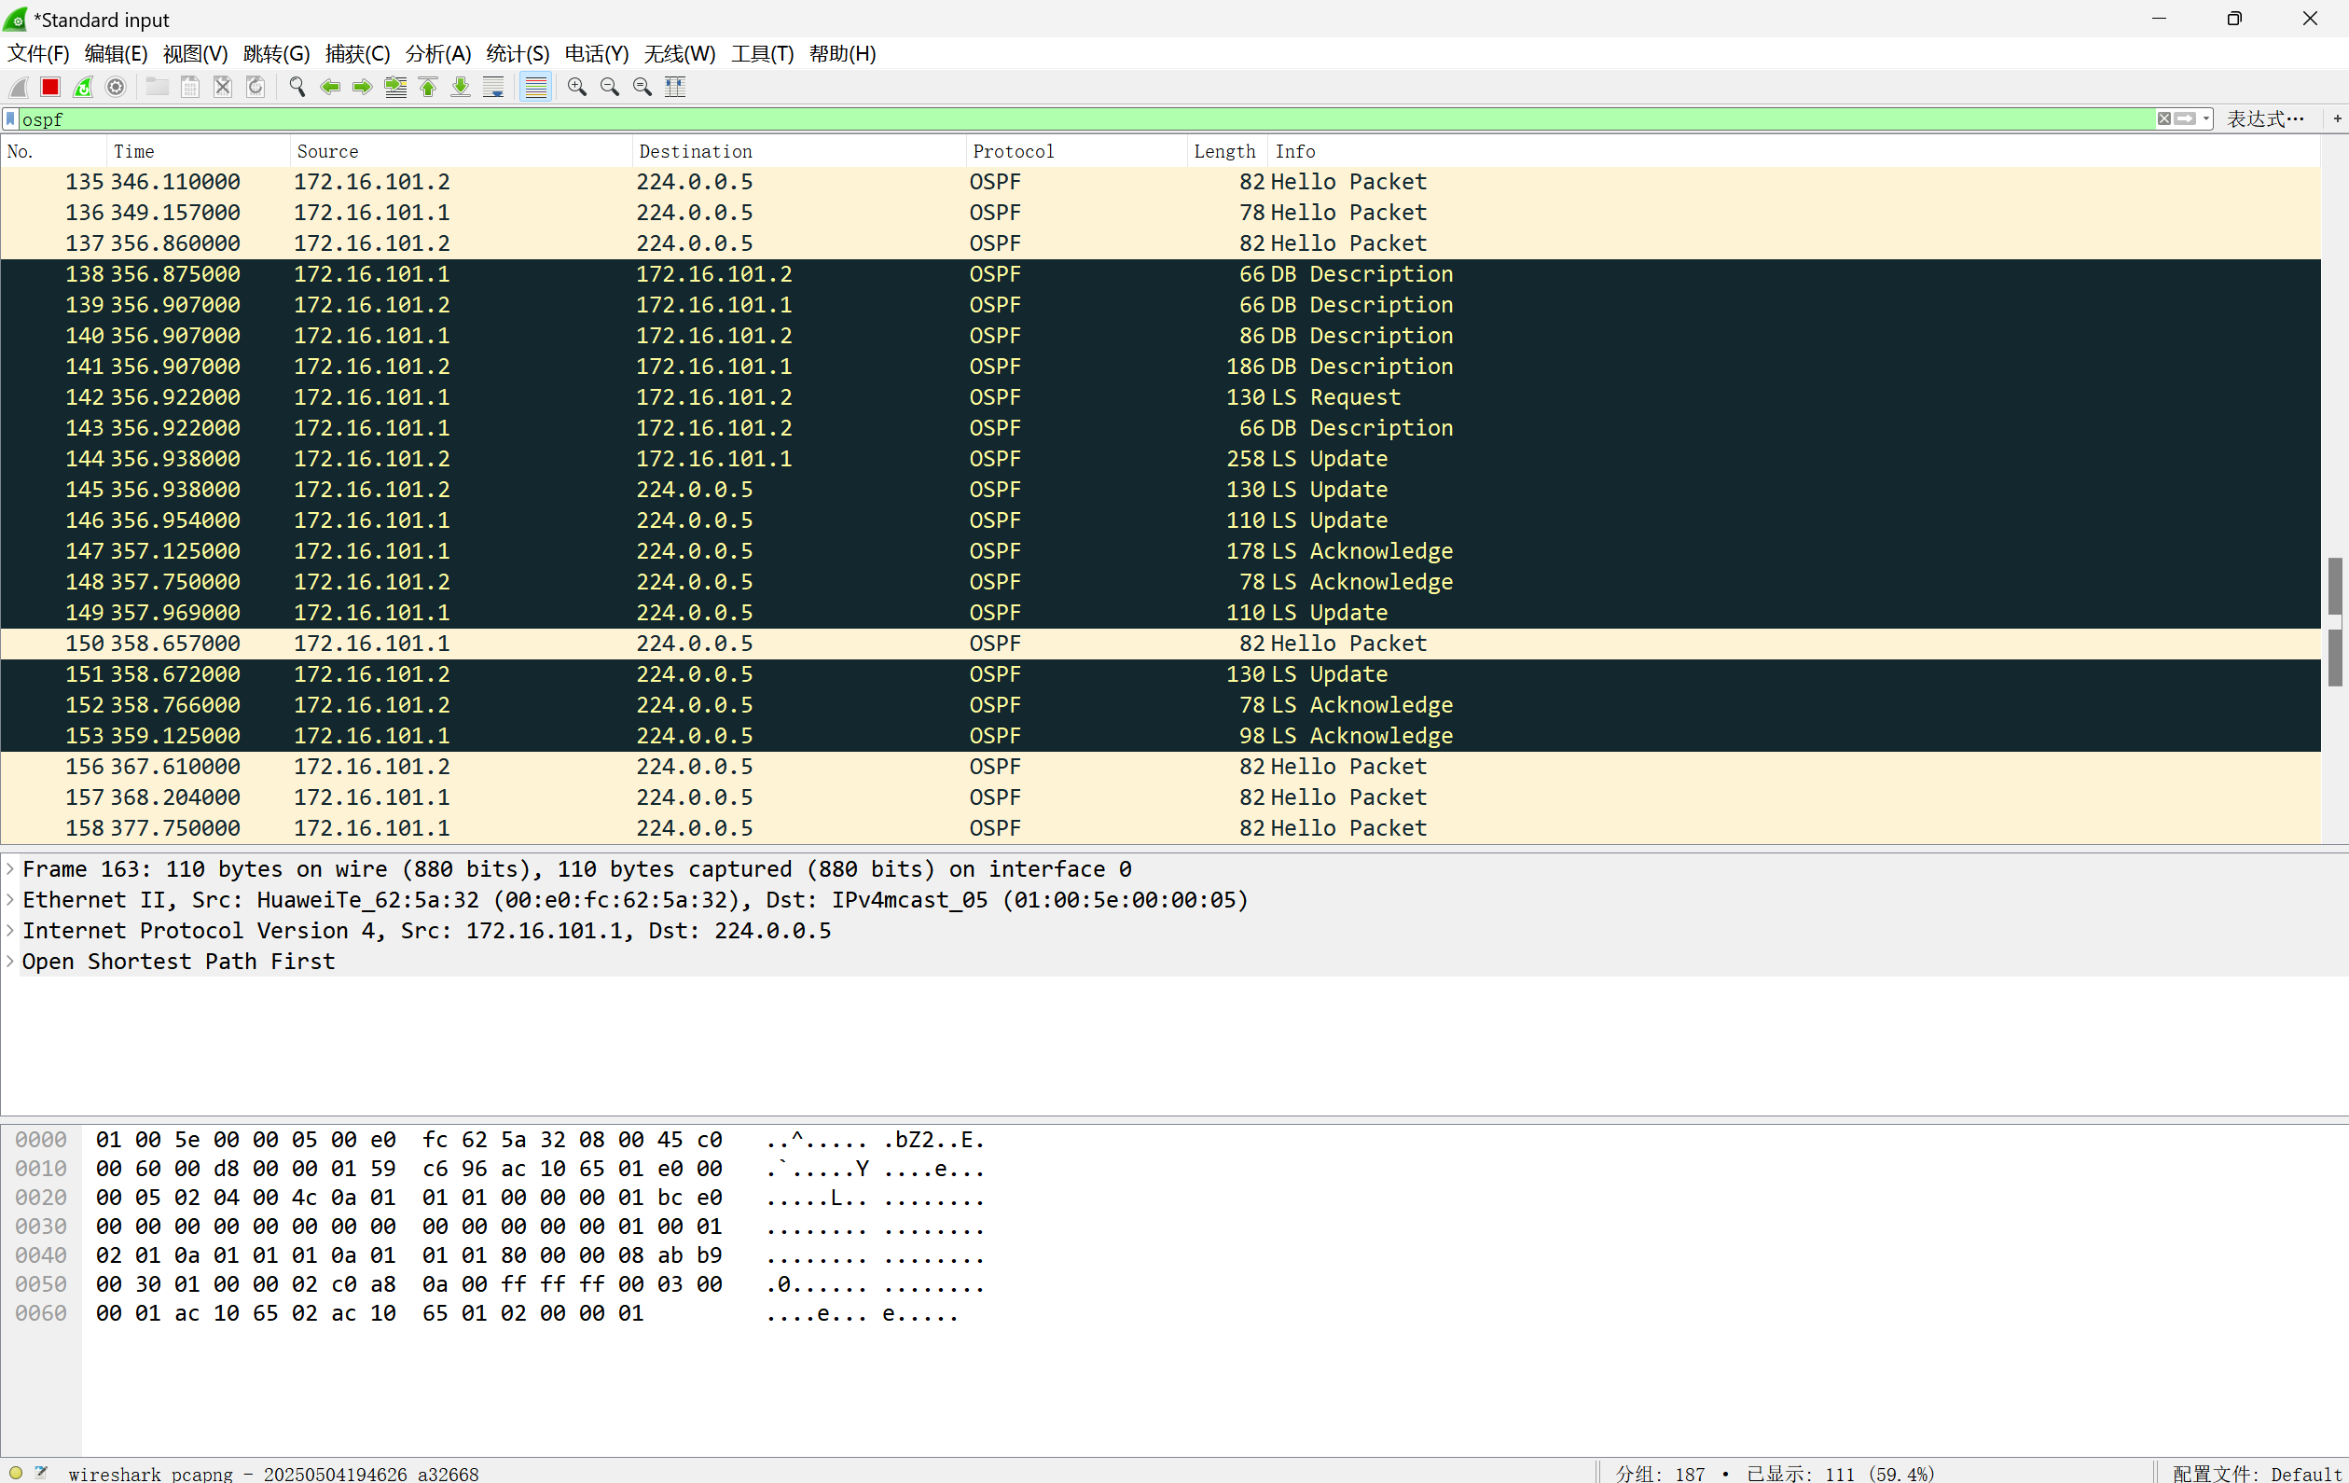
Q6-1.12. What OSPF packets are sent and received from the interface GE 0/0/0 and GE 0/0/1 on RTC? Paste the screenshot of the captured OSPF packets.
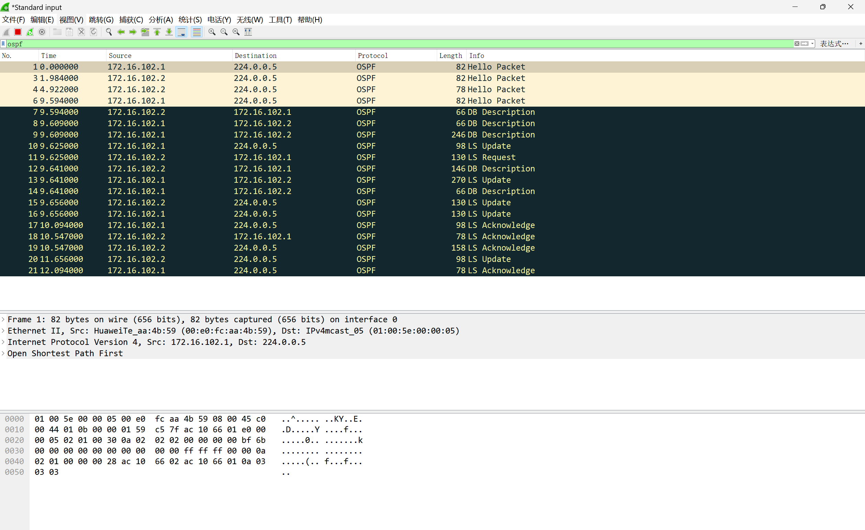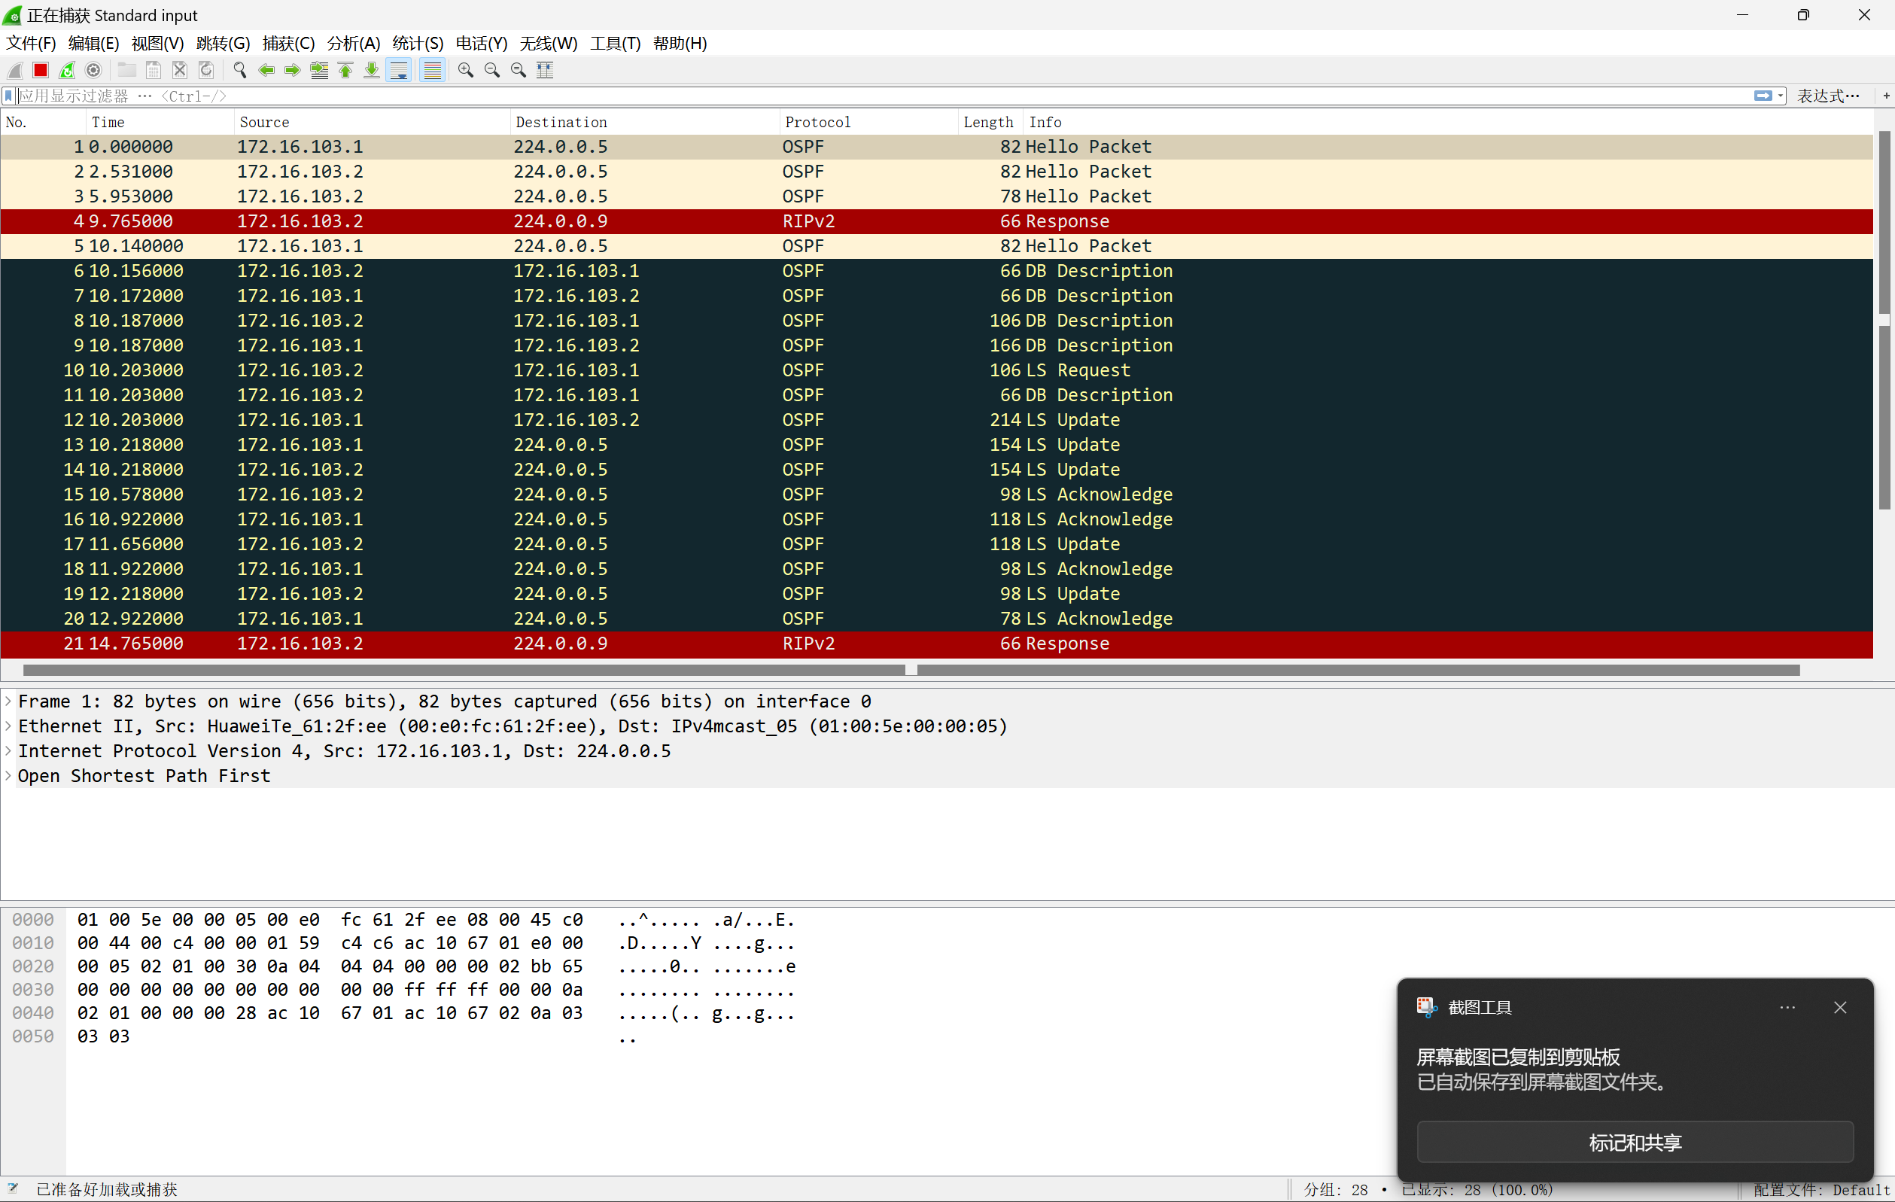
Q6-1.13. In what type of packet are the OSPF Link State Advertisements sent from the interface GE 0/0/0 on RTB transmitted? What are their LSA types? Paste the screenshot of the expanded information of the captured LSAs.
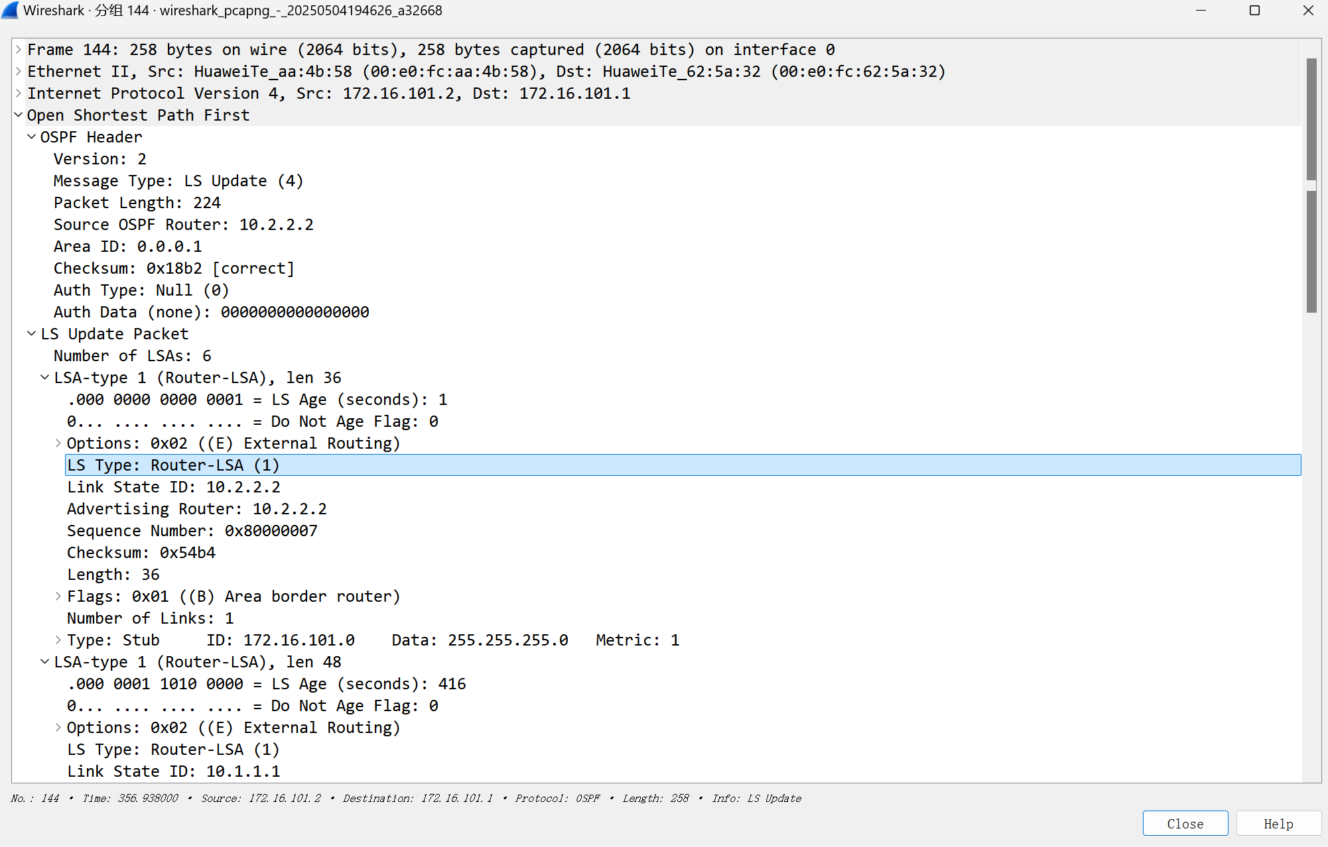
The Link State Update (LSU) packet carries Link-State Advertisements (LSAs) to facilitate the dissemination of routing and topology information across the network

Q6-1.14. In what type of packet are the OSPF Link State Advertisements sent from the interface GE 0/0/1 on RTB transmitted? What are their LSA types? Paste the screenshot of the expanded information of the captured LSAs.
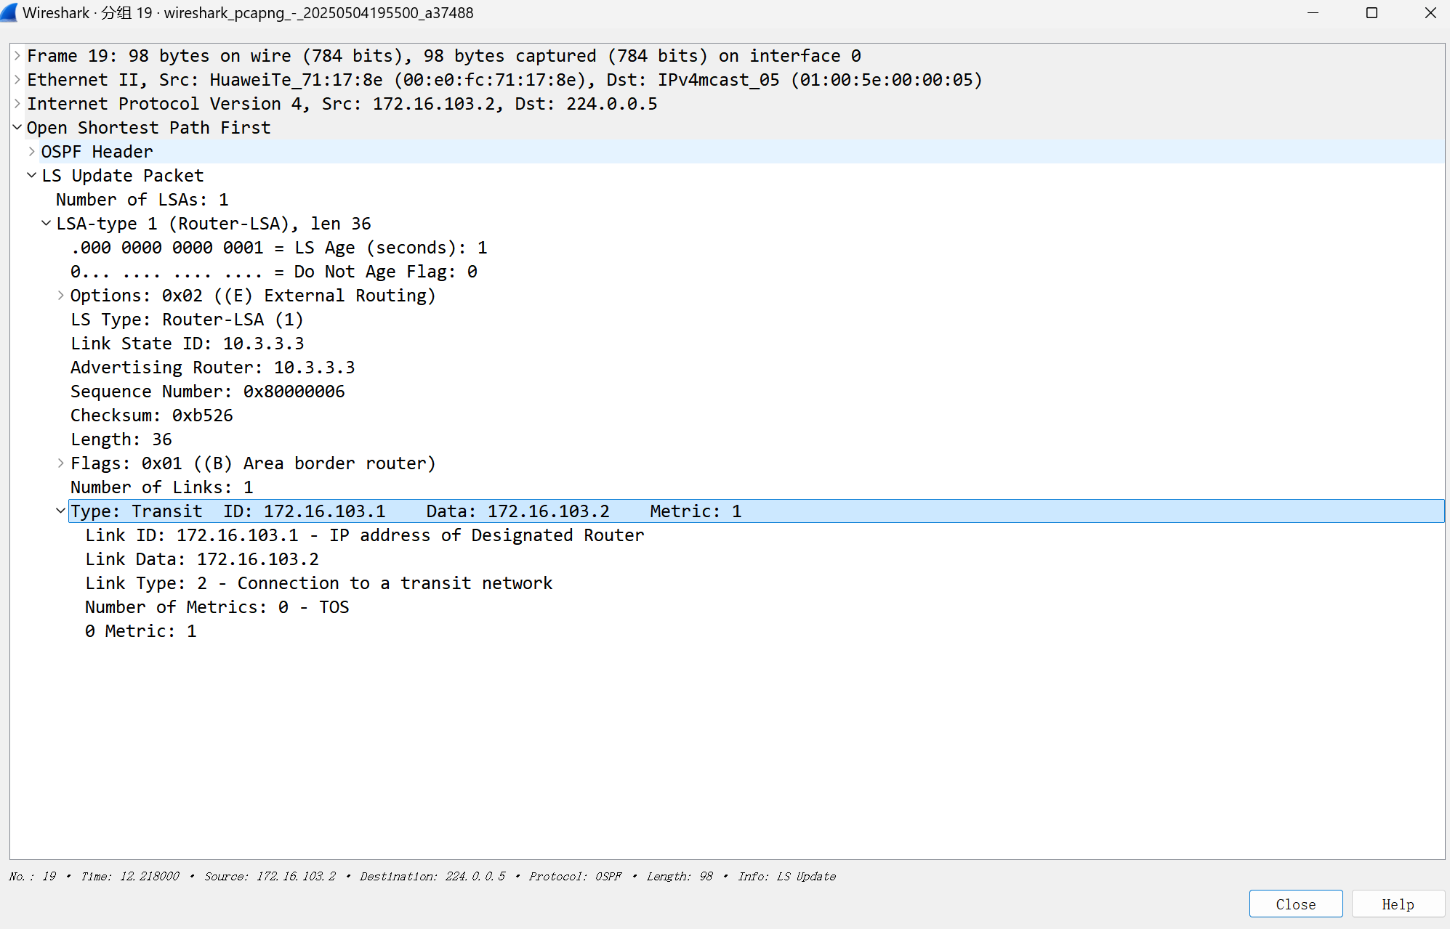
Q6-1.15. How are the Link State Advertisements in area 1 transmitted to area 2 through area 0? Please explain with the captured OSPF communications.
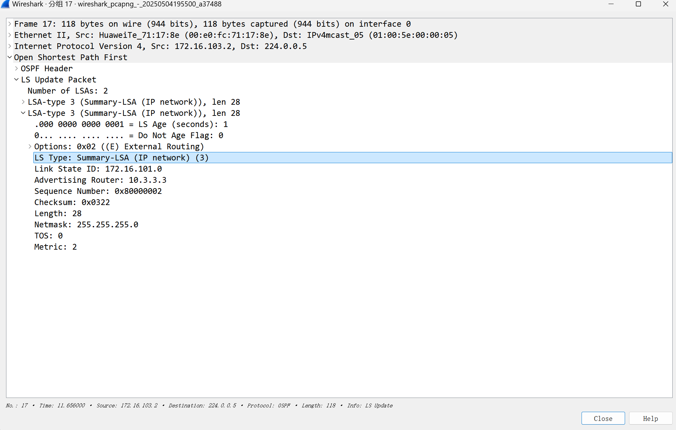
Area Border Routers (ABRs) are responsible for disseminating inter-area routing information between different OSPF areas, thereby ensuring inter-area route reachability.
Q6-1.16. How are the Link State Advertisements in area 2 transmitted to area 1 through area 0? Please explain with the captured OSPF communications.
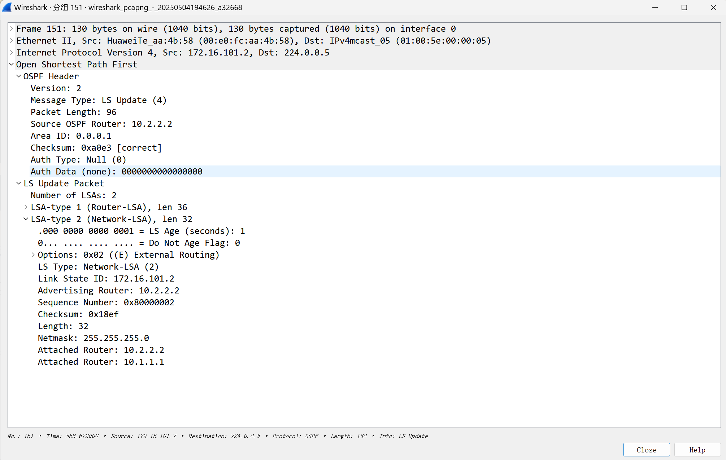
In OSPF, Area Border Routers (ABRs) use Type-3 LSAs, also known as Summary LSAs, to advertise inter-area routing information into Area 2, enabling route reachability between different areas.

